N E W R E L E A S E I N F O R M A T I O N
J U L Y − D E C E M B E R 2 0 1 9

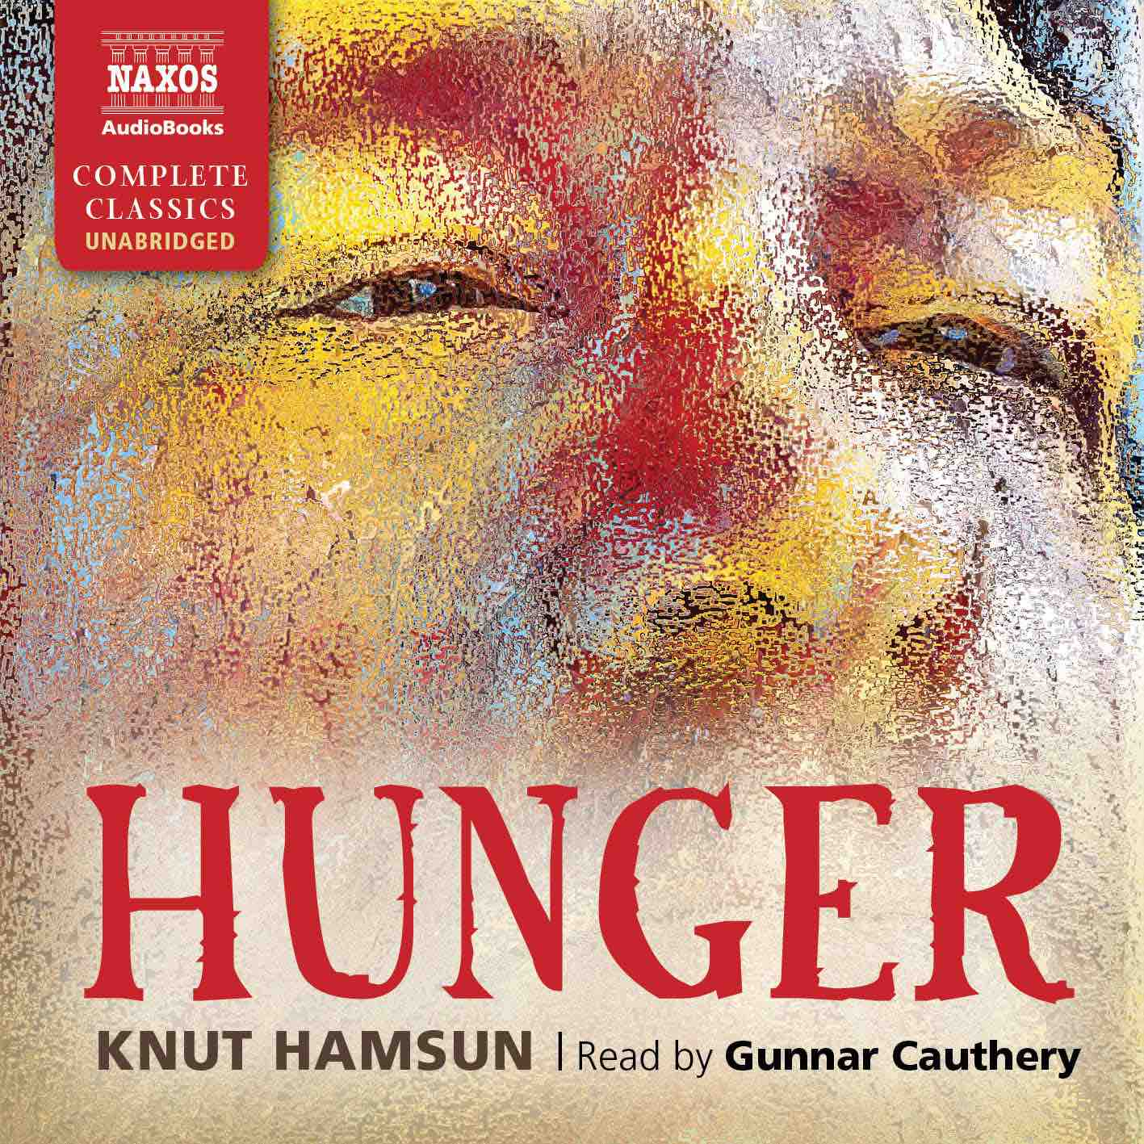

 | Cat No. | ISBN | Title | Hrs | Price | Author | Reader
Jul | NA0364 | 978-1-78198-247-1 | RIGHTS OF MAN | 9.5 | £19.50 | Thomas Paine | Matt Addis
 | NA0365 | 978-1-78198-249-5 | CAMILLA | 37.5 | £59.00 | Fanny Burney | Lucy Scott
 | NA0366 | 978-1-78198-251-8 | FROM THE EARTH TO THE MOON AND AROUND THE MOON | 12 | £23.00 | Jules Verne | Bill Homewood
Aug | NA0367 | 978-1-78198-253-2 | LA RABOUILLEUSE | 12 | £23.00 | Honoré de Balzac | Bill Homewood
 | NA0374 | 978-1-78198-267-9 | THE VIRGINIAN | 15 | £27.00 | Owen Wister | Robert G. Slade
 | NA0368 | 978-1-78198-255-6 | THE BHAGAVAD GITA | 3 | £9.00 | N/A | Sagar Arya
Sep | NA0363 | 978-1-78198-245-7 | THE DUKE’S CHILDREN | 32 | £52.00 | Anthony Trollope | David Shaw-Parker
 | NA0369 | 978-1-78198-257-0 | THE ANALECTS | 4 | £11.00 | Confucius | Bruno Roubichek
 | NA0370 | 978-1-78198-259-4 | FULL TILT | 9.5 | £19.50 | Dervla Murphy | Emma Lowe
Oct | NA0371 | 978-1-78198-261-7 | THE TRAGIC MUSE | 20 | £36.00 | Henry James | Gareth Armstrong
 | NA0372 | 978-1-78198-263-1 | IVANHOE | 19.5 | £36.00 | Sir Walter Scott | David Rintoul
 | NA0194 | 978-1-78198-882-8 | HUNGER | 6.5 | £16.00 | Knut Hamsun | Gunnar Cauthery
Nov | NA0373 | 978-1-78198-265-5 | THE HOUSE OF THE SEVEN GABLES | 11 | £21.50 | Nathaniel Hawthorne | Adam Sims
 | NA0193 | 978-1-78198-013-2 | SYBIL | 19 | £36.00 | Benjamin Disraeli | Tim Bentinck
 | NA0215 | 978-1-78198-014-9 | THE HOUSE OF MIRTH | 15 | £27.00 | Edith Wharton | Laurel Lefkow
 | NA0349 | 978-1-78198-220-4 | ZENO’S CONSCIENCE | 17 | £33.00 | Italo Svevo | Sean Barrett
Dec | NA0375 | 978-1-78198-269-3 | NJÁLS SAGA | 14 | £27.00 | N/A | Gunnar Cauthery
 | NA0251 | 978-1-78198-130-6 | THE ART OF LITERATURE | 4 | £11.00 | Arthur Schopenhauer | Mark Meadows

